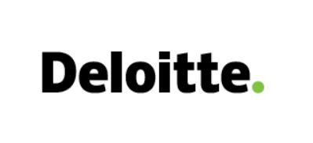

Fraud Discussion Meeting

|  |  |
| --- | --- |
| Client | Cosmopolitan Industries (Pvt.) Limited |
| Task Nature and Period | Group reporting and statutory audit for the year ended 30 June  2022 |
| Time | 4.00 PM – 5.30 PM, 26 June 2022 |
| Location | Virtual Media (Microsoft Teams) |
| Required Attendees | * Mr. Faruk Uddin Ahammed - Audit Partner * Salauddin Morshed - Audit Manager * Mr. Mizanur Rahman - Team In-charge * Imtiaz Rashid - Team Member * Sudipto Sarker - Team Member |

Agenda

**Tentative Discussion Issue:**

* Fraud triangle
* Going concern

< **END** >